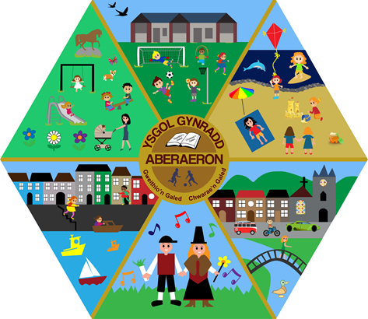

Revised Child Protection and Safeguarding Policy
Ysgol Gynradd Aberaeron
October 2025

Revised Child Protection and Safeguarding Policy
Ysgol Gynradd Aberaeron
October 2025

Introduction
Ysgol Gynradd Aberaeron fully recognises its responsibility to safeguard and promote the welfare of children. Our policy contains three main elements:
- Prevention through the teaching and pastoral support offered to pupils
- Procedures for identifying and reporting cases, or suspected cases, of abuse. Due to their daily contact with children, school staff are well placed to observe possible signs of abuse
- Support for pupils who may have been abused
This policy applies to all staff, governors and volunteers working in the school.
The policy will be reviewed annually.

Confidentiality
Confidentiality issues must be understood if a child discloses abuse. A child may not feel confident to trust a member of staff if they believe the information will be shared with others indiscriminately. However, education staff have a professional responsibility to share relevant child protection information with designated statutory agencies when there are concerns about a child’s welfare.
Staff must deal with this sensitively and explain to the child that they must inform the appropriate professionals who will be able to help, but that the information will only be shared with those who need to know. Staff should reassure the child and explain that not everyone in school will be aware of the situation.
It must be remembered that the child has likely shown great bravery in disclosing information and may experience conflicting emotions, such as guilt, embarrassment, betrayal (particularly if the abuser is known to them), and distress.
All child protection records are confidential and must only be accessible to those with a professional role, e.g. the Designated Safeguarding Person (DSP) and the Headteacher. Records must be stored securely, under lock and key, and separately from the child’s main school file.
The Designated Safeguarding Person at this school is:
Mrs Anwen Lloyd-Hughes

Prevention
The school recognises that high self-esteem, confidence, supportive friendships and good communication with trusted adults help to safeguard pupils.
The school will therefore:
- Establish and maintain an ethos where pupils feel secure, are encouraged to talk, and are listened to
- Ensure pupils know that there are adults in school they can approach if they are worried or in difficulty
- Include within the curriculum Personal and Social Education activities that equip pupils with skills to protect themselves and know where to seek help
- Include curriculum content that helps pupils develop realistic attitudes to adult responsibilities, particularly in relation to childcare and parenting skills

Procedures

Procedures to be followed if there is a child protection disclosure or concern
The school adheres to the Wales Safeguarding Procedures 2019, approved by the Local Safeguarding Children Board.
The school will:
- Ensure there is a suitably trained Designated Safeguarding Person (DSP)
- Ensure all staff and governors know:
  - The name and role of the DSP
  - The governor with responsibility for safeguarding (Rachel O’Connor)
  - Their individual responsibility to report safeguarding concerns promptly
- Ensure staff are alert to signs of abuse and know how to respond to a disclosure
- Ensure parents understand the school’s safeguarding responsibilities through information in the school prospectus
- Ensure staff receive appropriate safeguarding training relevant to their role
- Provide safeguarding briefings at least once per term
The school will inform Children’s Services if:
- A pupil on the Child Protection Register is excluded
- A pupil on the register is absent for more than two days without explanation
Written records of concerns will be kept, dated and securely stored.

Making a Child Protection Referral
Ceredigion Children and Families Assessment Team
- Porth Gofal: 01545 574000
- Out of hours: 0300 456 3554
- Designated Child Protection Officer – Education Services:
01970 633668 / 07977 510316
- Police: 101
- Emergency: 999
Copies of referrals must be sent to the Designated Officer for Education Services.

Responding to a Disclosure

Listen
Listen carefully without showing shock or disbelief.

Reassure
Do not promise confidentiality. Reassure the child that they are not to blame.

Respond
Ask only open questions. Do not investigate.

Record
Record the child’s exact words as soon as possible. Date and sign records.

Report
Pass information immediately to the DSP.

Managing Allegations Against Adults
Any allegation against a member of staff must be reported immediately to the Headteacher.
If the allegation concerns the Headteacher, it must be reported to the Chair of Governors and the named senior officers.
The school will follow local authority procedures and seek advice from Children’s Services as required.

Supporting Pupils at Risk
The school recognises that abuse can have a significant emotional impact on children. Support includes:
- Taking all concerns seriously
- Maintaining confidentiality
- Providing appropriate pastoral support
- Working closely with external agencies
When a child on the Child Protection Register transfers schools, safeguarding records will be transferred securely and promptly.

Physical Intervention
The school’s Physical Intervention Policy is contained in a separate document and aligns with Welsh Government guidance on the safe and effective use of reasonable force. All staff completed Team Teach online training in May 2021.

Policy Review
This policy and Appendix A will be reviewed annually by the Governing Body.
Review date: 29/10/26

Appendix A – Responsibilities of the Designated Safeguarding Person
The DSP has overall responsibility for managing safeguarding concerns, making referrals, supporting staff, maintaining secure records, and liaising with statutory agencies.
The DSP must have sufficient authority, time and training to fulfil the role effectively.

Definitions and Indicators of Child Abuse
Child abuse includes physical, sexual and emotional abuse and neglect. Indicators include unexplained injuries, behavioural changes, emotional withdrawal, sexualised behaviour and persistent neglect of basic needs.

Abuse of a Position of Trust
Under the Sexual Offences Act 2003, it is a criminal offence for an adult in a position of trust to engage in sexual activity with a child under 18, regardless of consent.

📌 Polisïau diogelu llawn ac adnoddau ategol ar gael yn Teams – Staff Safeguarding Folder.

